* 1. Taxi-booking app
     + Functional
       - Ability to create a booking
* Ability to contact taxi drivers
* Ability to cancel/modify a booking
  + - Data
      * Data needs to be sent securely from the smartphone to the app’s servers.
      * Location data and journey logs should be stored for a few weeks so that if someone goes missing the police could see where their taxi took them
      * The location data should be stored securely such that hackers cannot access them.
      * If payments are made through the app, then payment details need to be stored securely.
    - Environmental
      * Needs to work in the rain (which might make it difficult to tap small buttons on a phone screen)
    - User characteristics
      * Will probably have some familiarity with technology/smartphones (technophobes would probably choose to book by phone call instead)
      * Might have a wide range of impairments such as poor eyesight. Accessibility features (text to speech, high-contrast mode, etc.) would be necessary.
    - Usability goals
      * Safety (it should be easy to check that the car that arrives is in fact the taxi you booked)
      * Ease of use (it should be easy to use when drunk or otherwise unable to drive oneself)
    - User experiences
      * Should be aesthetically pleasing
      * Low effort to use
  1. Air traffic control system
     + Functional
* See all scheduled take-offs and landings
* Schedule new take-offs and landings
* Check for clashes
* Alerts/notifications if schedules change
  + - Data
      * Scheduled take-off and landing data needs to be stored in an OLTP database until they occur and then maybe aggregated in an OLAP database for years afterwards
      * Would have to synchronise its data with all the other air traffic control systems
    - Environmental
      * Would have to function in a very crowded environment
      * Must be easy to use even in a very noisy environment
    - User characteristics
      * Would be well-trained air traffic controllers
      * The same system might be used by multiple users
    - Usability goals
      * Should be easy to tell if mistakes were made
      * Should be very difficult to accidentally input the wrong information (typo-resistant)
      * Warnings and errors should be clear and difficult to miss
      * Should be easy to use even under a lot of stress/pressure
    - User experiences
      * Users should feel confident that they could not have made any mistakes
      * The system will likely have to be used many times in a day, so the user should be able to use the system multiple times without getting too bored/irritated
  1. A conceptual design describes how a system should theoretically function in general, without going into detail about the implementation. A physical design goes into specific detail about how the system will function and be implemented in the real world, and how the physical limitations of the space will be addressed.
     + Users can “browse” the items for sale by category or by searching in a search bar. This is analogous to a real shop in which the items are arranged by category, and you can ask a shop assistant to help you locate a specific item
     + Users can select an item and see its price (which is analogous to the price tags in real shops) and see information about the product, as well as reviews from people who have bought it before (which is rarely possible in a real shop
     + Users can add the item to their “basket” to indicate that this is something they want to buy. This is of course analogous to the physical shopping basket one might use in a real shop
     + Users can remove items from their basket (also possible in a real shop)
     + Users can “checkout” when they are ready to purchase everything in their basket by entering some payment details. They usually do not have the option to pay with cash like they probably would in a physical shop
     + Users can review their previous purchases and be given recommendations of which items they might like to purchase in the future. These are services not offered by physical shops.
     + Users can track items which are out for delivery. This is not applicable to most physical shops where you simply walk out with the item you want.
  2. 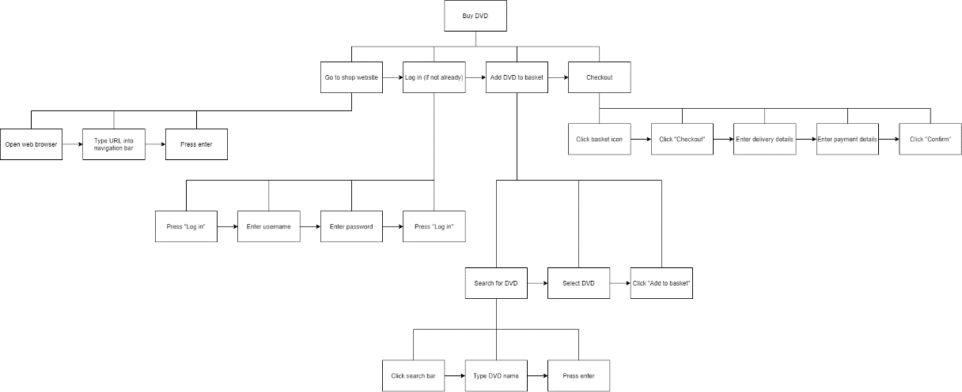In order to buy a DVD online one must first go to the shop’s website. This consists of opening their web browser, typing in the shop’s URL, and pressing enter. Then if they are not already logged in, the user must do so. This involves clicking “Log in”, entering their username and password, and then clicking “Log in” again. They must then add the DVD to their basket. This means searching for the DVD (Clicking on the search box, typing in the DVD’s name, and pressing enter), clicking on the DVD they want, and then clicking “Add to basket”. They must finally checkout. To do this, they click on the basket icon, click “Checkout”, enter their delivery address, enter their payment details, and click “Confirm”.

* + - Humans are better at drawing on experience and adapting decisions than computers are. This balance is achieved in the example by the human specifying how the car should move (forwards, left, right, etc) rather than simply a location of where the car should go
    - Humans are better than machines at acting in emergency situations. This balance could be achieved in the example by reacting to a human emergency signal (e.g., saying the word “STOP” or giving a certain hand gesture) and immediately engaging in a predefined emergency protocol (e.g., activating the brakes)
    - Machines are better at exerting great or precise forces than humans are. This balance is achieved in the example by the machine physically manoeuvring the vehicle, rather than the human doing it.
    - Machines are better at making precise movement than humans are. This balance could be achieved in the example by accepting a wide range of similar gestures, and mapping down to the same 6 categories (i.e., making it so that it does not matter if the human gets the gestures slightly wrong; it will still be understood)
  1. Diagram

     Description automatically generated
  2. Task analysis can help identify when simple/common tasks take too much effort to carry out. For example, if a task analysis for an online shop revealed that searching for a product took 10 steps each of which could be broken down into 10 sub-steps, that information would help the developers redesign the system to make this task simpler.